Problem 2: Sparse Representation of Graphs (CSC)
Compressed Sparse Column (CSC) format uses col_pointers to indicate where each column's data begins in the row_indices array.

Indices: A→0,B→1,C→2,D→3,E→4.

Graph 1 (Undirected)

Col A (0): row_indices[0:2] → Rows 1, 2 (Edges: A-B, A-C)

Col B (1): row_indices[2:5] → Rows 0, 2, 3 (Edges: B-A, B-C, B-D)

Col C (2): row_indices[5:8] → Rows 0, 1, 3 (Edges: C-A, C-B, C-D)

Col D (3): row_indices[8:11] → Rows 1, 2, 4 (Edges: D-B, D-C, D-E)

Col E (4): row_indices[11:12] → Row 3 (Edge: E-D)

- Adjacency Matrix (Graph 1):
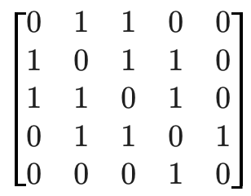
(b) Graph Diagram Description:
This is a "diamond" shape where A, B, C, and D are highly interconnected, and E is a "leaf" node attached only to D.

Graph 2 (Directed)

Col A (0): col_pointers[0] to col_pointers[1] is 0→0 (No incoming edges).

Col B (1): row_indices[0:2] → Rows 0, 3 (Edges: B → A, B → D)

Col C (2): row_indices[2:4] → Rows 0, 1 (Edges: C → A, C → B)

Col D (3): row_indices[4:5] → Row 2 (Edge: D → C)

Col E (4): row_indices[5:7] → Rows 1, 3 (Edges: E → B, E → D)

- Adjacency Matrix (Graph 2):
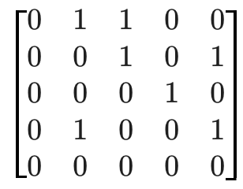
Note: Since it is CSC, the row index i in column j indicates an edge i←j or j→i. Values above reflect j→i mapping.)

(c) Unique Cycle in Directed Graph:
By tracing the edges: B→D, D→C, and C→B.
Cycle: B→D→C→B

